UAH Fit Vault Rough Order Estimate(ROM)

**Introduction**

The document provides the basis for a project complexity estimate for the UAH Fit Vault web application software project. The document will be separated into three parts. The first part of this document will include a work breakdown structure showing the major components of the system and their subsystems. There will then be a brief description of the features needed to create the software application. Lastly the estimation will include function point analysis which will then be converted into lines of code.

**Summary**

The following shows the estimation for the two systems based on the Function Point estimates below. Based on the Function Points to Lines of Code reference listed the conversion of Function Points to Lines of Codes ranges from 40 to 80 per Function Point. The Lines of Code estimate assumes that C# is the programming language being used.

|  |  |  |  |
| --- | --- | --- | --- |
| Software | Function Point Total | Min LOC | Max LOC |
| UAH Fit Vault | 106 | 4240 | 8480 |

**References**

* Fundamentals of Function Point Analysis (http://www.softwaremetrics.com/Function%20Point%20Training%20Booklet%20New.pdf)
* Function Points to Lines of Code (<http://www.codeproject.com/Articles/701642/Software-Estimation-by-example>)
* Pressman, R. (2010). *Software Engineering: A Practitioner's Approach* (7th ed., pp. 619-622). New York, NY: McGraw-Hill.

**UAH Fit Vault**

**Work Breakdown Struction**

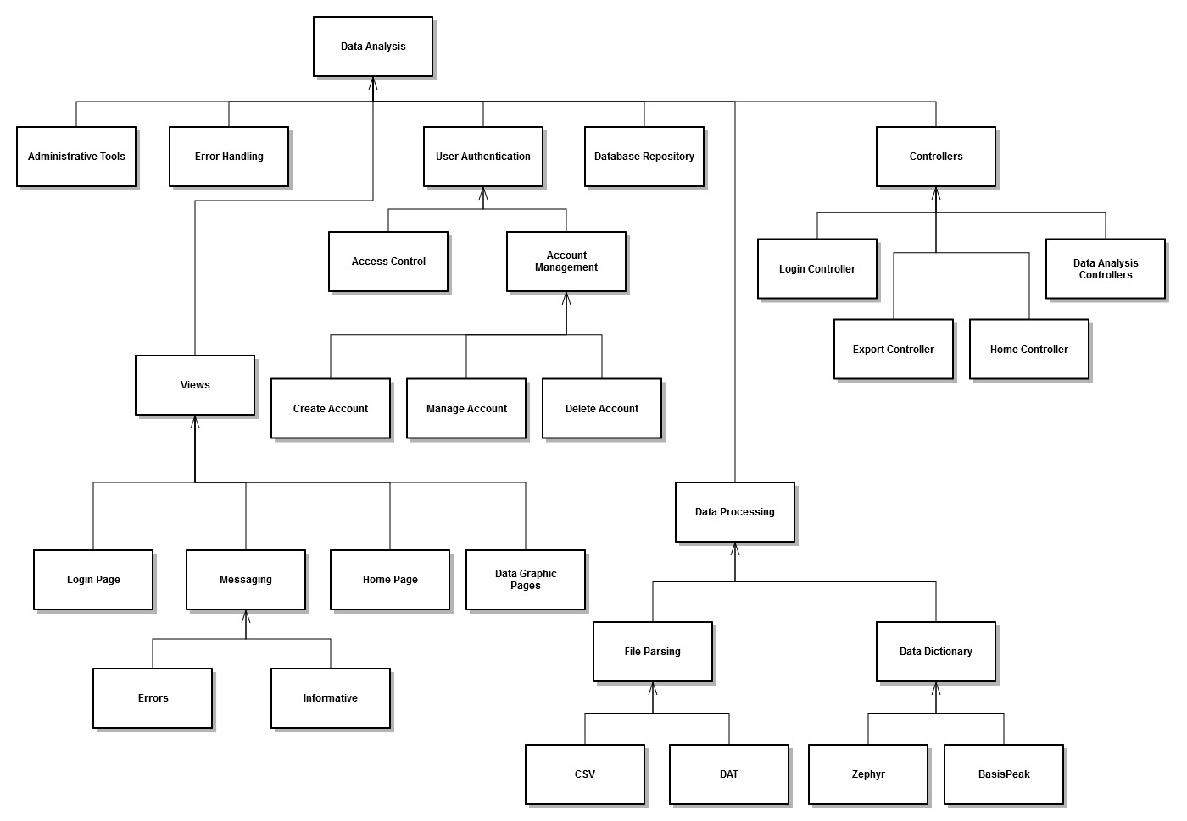

## Feature List and Description

* **Administrative Tools**

This represents the features that will be available to a system administrator of this software.

* **Error Handling**

In the event that a problem occurs during data upload, database connection, user authentication, or any other process in the system there needs to be a way to handle the errors that occur.

* **Login Page**

This represents the view for the login page.

* **Home Page**

This represents the view for the home page a user will be directed to after logging in. This will contain the navigation links to the rest of the features of the website.

* **Error Notification**

Error message display for the GUI.

* **Informative Notification**

Any other message that made need to be displayed to the user that is not an error message.

* **Data Graphic Pages**

This represents the various views and pages that will display graphical or informative data that represents the medical data analysis.

* **Access Control**

Manages what users have access to what data.

* **Create Account**

Function to create a new user account.

* **Manage Account**

Function to manage an existing account.

* **Delete Account**

Represents an administrative function for deleting an existing account.

* **Login Controller**

Application logic used to control the login system.

* **Home Controller**

Application logic used to control the home page.

* **Data Analysis Controllers**

Application logic to control the various data analysis pages.

* **Export Controller**

This feature will allow a user to export a medical report to their hard drive for their record.

* **Database Repository**

Consists of all the functions need to access data from the database.

* **Drag and Drop**

Allows for files to be dragged into the Graphical User Interface (GUI) so they can be processed. The drag and drop functionality will support single or multiple files.

* **Directory Browsing**

Instead of dragging files into the GUI, this feature will allow the user to browse to a specific directory on the computer, and the files in that directory will be processed.

* **CSV File Processing**

There are .csv files that will need to be processed that contain medical data from both devices.

* **DAT File Processing**

The Zephyr device also has .dat files that will need to be processed along with the .csv files.

* **Zephyr Data Dictionary**

This is meant to describe any functionality need to understand what data is being read in to the system from the various Zephyr dat or csv files.

* **BasisPeak Data Dictionary**

This is meant to describe any functionality need to understand what data is being read in to the system from the BasisPeak csv files.

## Function Point Analysis

|  |  |  |  |  |
| --- | --- | --- | --- | --- |
| Type of Components | Complexity of Components | | | |
|  | Low | Average | High | Total |
| External Inputs | **6** x 3 | **0**x 4 | **0** x 6 | 18 |
| External Outputs | **3** x 4 | **0** x 5 | **1** x 7 | 19 |
| External Inquiries | **1** x 3 | **1** x 4 | **0** x 6 | 7 |
| Internal Logical  Files | **6** x 7 | **2** x 10 | **0** x 15 | 62 |
| External Interface  Files | **0** x 5 | **0** x 7 | **0** x 10 | 0 |
| Total Unadjusted Function Points (UAP) | | 106 |
| Value Adjustment Factor (VAF) | | 1.00 |
| Total Function Points | | 106 |

**External Inputs**

|  |  |
| --- | --- |
| Name | Complexity |
| Login Page | Low |
| Home Page | Low |
| Create Account | Low |
| Manage Account | Low |
| Delete Account | Low |
| Administrative Tools | Low |

**External Outputs**

|  |  |
| --- | --- |
| Name | Complexity |
| Error Messaging | Low |
| Informative Messaging | Low |
| Data Graphic Pages | High |
| Export Controller | Low |

**External Inquiries**

|  |  |
| --- | --- |
| Name | Complexity |
| Access Control | Low |
| Data Repository | Average |

**Internal Logical Files**

|  |  |
| --- | --- |
| Name | Complexity |
| Login Controller | Low |
| Home Controller | Low |
| Data Analysis Controllers | Average |
| Error Handling | Low |
| Zephyr Data Dictionary | Low |
| BasisPeak Data Dictionary | Low |
| CSV File Processing | Average |
| DAT File Processing | Low |

**Value Adjustment Factor**

|  |  |
| --- | --- |
| General System Characteristic | Score |
| Does the system require reliable backup and recovery? | 1 |
| Are specialized data communications required to transfer information to or from the application? | 5 |
| Are there distributed processing functions? | 5 |
| Is performance critical? | 3 |
| Will the system run in an existing, heavily utilized operational environment? | 0 |
| Does the system require online data entry? | 5 |
| Does the online data entry require the input transaction to be built over multiple screens or operations? | 1 |
| Are the ILFs updated online? | 1 |
| Are the inputs, outputs, files, or inquiries complex? | 4 |
| Is the internal processing complex? | 3 |
| Is the code designed to be reusable? | 0 |
| Are the conversion and installation included in the design? | 3 |
| Is the system designed for multiple installations in different organizations? | 0 |
| Is the application designed to facilitate change and ease of use by the user? | 4 |
| Total | 35 |
| VAF = 0.65 + (0.01* ΣFi) | 1.00 |